

**Phishing**

**Harrison Watycha**

**Executive Summary:**

The phishing threats within the Deakin VR module is specifically designed to educate and inform small businesses and the staff who are employed within that business to be aware of phishing threats (traits, characteristics, etc) and to also assist preventing phishing frauds being successful. This module will use real-world examples and through VR, we will train the employees to be able to handle and prevent phishing. The goal of this module also includes the setup of a preventative measure to prevent phishing being successful regardless of an employee falling for a phishing email. This preventative measure will be Multi Factor Authentication, the research in this module will indicate why this will be a successful preventative. VR is effective because it provides an immersive factor and experience for the user, making it more engaging and effective training.

**Learning Objectives: For inexperienced users to:**

* Understand the danger and hazards of phishing frauds
* Identify common threats of phishing
* Create processes and systems to identify phishing
* Educate business on processes to prevent phishing frauds becoming successful
* Implement a method to stop phishing = MFA
* At least 80% of setup MFA success rate
* Identify phishing 80% of the time

**What is phishing:**

Phishing is typically and most commonly a fraudulent behaviour and action that is conducted on the medium of email. It is when an attack sends a fake email normally from a source that is legitimate (Government, Bank, Healthcare etc), but it is not coming from any legitimate source. Instead, it typically contains a malicious link, that once clicked infects the victim's computer with a bug or virus. Additionally, the email sent is often quite intensive, it will use language to stress the victim and make them act out of fear and pressure them to click the link. Additionally, phishing is like Smishing however that is through SMS, phishing is through email.

**What are the consequences of letting a phishing email be clicked:**

* The consequences for a successful phishing email are not good for the business, it has been found that in the worst case it can even lead to identify theft which can lead to other consequences, additionally.
* Loss of money, direct funds transfer
* Loss of client's data and information, which leads to loss of clients potentially
* Loss of personal data
* Disruption to infrastructure and system
* Can even hurt a business's reputation
* Legal consequences, depending on the country the business resides in there is sometimes legal consequences for data breaches.

**Implementation Strategy for Phishing:**

The strategy to incorporate all this theoretical work and research will be done through the application of Unity using their VR environment. This is because the unity environment provides a super user-friendly environment that is centred around educating users on topics like phishing.

Additionally, unity offers the capabilities to display phishing modules and to create interactive moments for the user. This is effective because it makes the experience more engaging and that leads thhe user being more likely to remember the core work being shown.

Finally, the strategy will include assets from the unity asset store. These assets will make the experience more intercative and more realistic, which again will lead to the user experiencing the VR session to remember the content that is being displayed to them.

**Narration (Draft):**

In this scenario, users will be exposed to common phishing frauds and practices that are common when targeting office environments. In this scenario, consequences of falling for phishing frauds will be highlighted, and the extent of their damage will be highlighted. In addition, avoidance tips will be discussed and explored. As well as methods that you the business can implement to prevent phishing frauds from being successful. I also want the story to run through the office with the host beginning the experience at the start with the introduction and brief overview of what is going to happen. Before moving to an open meeting room, in which the host explains breach has occurred, following that the user will be exposed to a mini game of selecting which email is safe and which email is not safe. Once the user can identify the difference, the location will move to a more IT room. In this IT room the user will setup the MFA which in this example will be duo mobile, this will be done via a VR code. In the meantime, the host will be explaining how the app works and help the user getting setup. Following that the host will explain how this stops phishing.

**Key challenges:**

1. **User ability**: i.e. Novice users. This is quite a common issue in my research of this module. Especially for MFA
2. **Lack of awareness:** About what a legitimate phishing email looks like, characteristics, features etc.
3. **Effective phishing techniques:** Utilising intensive and pressuring language, this encourages urgency and leads to the victim not having time to think.
4. **Complex VR system:** VR is not well known to me yet, and this could be hard to achieve.
5. **Lack of supporting software:** Running the software itself can be expensive, and most small business will not use it.
6. **Lack of resources:** If a business does not have capability to install this MFA strategy and or purchase the equipment that would set it up.

**Key Takeaways:**

1. **MFA:** Multi Factor Authentication can play a huge significant role in preventing phishing becoming successful. Even if a link is clicked the hacker would not be able to be approved by another team member.
2. **Cannot just be MFA:** This VR module will also educate; it will show the traits and characteristics of phishing emails, and this will raise awareness of what to look out for and what not to fall for.
3. **Phishing is getting more advanced:** Emails in this era are becoming increasingly believable, more legitimate sources are being impersonated.
4. **Continued work is required:** This should not be a one of training session, this and similar activities should be run continuously as refresher courses for workers.

**Why MFA (Multi Factor Authentication will be effective!**

1. **Layered Security Provided:** What layered Security means is essentially if something does go wrong and a link is opened or accessed by a member of staff, and it seems that there will be a significant data breach MFA essentially combines at least two different authentication factors, weather that is a pin, password or something you are.
2. **Provides Alerts:** As it will be shown on employee's mobile devices when a breach has occurred it will notify with ‘trying to access...’, this alone notifies the business that someone has attempted to access the system and allows the team to prevent data loss.
3. **Prevents the likelihood of Password attacks being successful:** The source of Shekokar (2015, pg.82) indicates that even if a hacker tricks or guesses the required password, this level of authentication will prevent from access is being provided.
4. **MFA success rate:** Provided by Microsoft in 2020, 99.9% of accounts comprised and breach were prevented by MFA.

**STORYBOARD:**

## **Storyboard Development Template for VR-Based Cybersecurity Training Module**

**Title: Phishing Storyboard**

1. Learning Objectives:
   1. Train the staff on the dangers of phishing, and what a phishing email looks like (characteristics, features)
   2. Train staff and get them setup on the MFA (Duo Mobile)
   3. Expose the staff to phishing and VR capabilities.
   4. Expose the staff to VR
   5. Train staff on even more complex phishing examples
2. Narrative Overview:
   1. The story will start with an introduction from the host in the door upon entering the business in which he explains why you are here.
   2. Following that you walk to the training room, in which there is a whiteboard
   3. Following that, the instructor informs you of a phishing fraud that was successful and has led to a breach in the business. Highlighting that this event is not good for the business
   4. The instructor then explains what phishing is, and most importantly explains the characteristics of what a phishing scam looks like. The host will also explain the interactive that is about to happen. In this game the user must select either safe or unsafe via a happy or sad face. That is in re action to an example that will be shown on the screen, and the host will explain the game.
   5. Next slide, using the whiteboard will show an email that is not safe, but not state that, the user will click a frowny face or a happy face (PHISHING)
   6. The slide after will show an email that is safe and is from a legitimate source and contains no phishing, and again, the instructor will explain why this is safe. Again, host will not say at the start and the user will click a sad face or happy face (NOT PHISHING)
   7. The third example will be an email that will be harder to tell then the others. It will not just be easy; it will contain a link and an attachment. However, this will be a safe email. (NOT PHISHING)
   8. The final example will be a similar email will have a link and an attachment. However, there will be a couple minor spelling mistakes that hopefully the user picks up on. (PHISHING)
   9. The next slide will be the end of the game, and the host will explain the next part of the VR process. Explain that we are moving to the lab, to setup MFA
   10. The next page is completely dedicated to the user downloading the MFA hopefully via QR code
   11. The next slide will show an example of the page setup of duo mobile, and gives a brief description of the app
   12. The second last slide is the complete version of the MFA app, with the host explaining how this prevents phishing.
   13. The final slide will be an example of the user approving a login request and showing that the app works. This also leads to a congratulations message.
   14. **Key challenges: QR code, mobile device being big enough, the game being able to run smoothly.**
3. Interactive Elements:
   1. Interaction 1: QR code, will lead to the mobile app. End goal
   2. Activity 1: On the whiteboard the first whiteboard will show an email that will be phishing, and the user will be invited to click a frowny face or a sad face.
   3. Interaction 2: Again, on the whiteboard except this time it will be a safe email, and the user will have the option between a sad face or a frowny face, from that a result will be given.
   4. Activity 2: QR code, will not really require any action from the user.
4. VR Environment Design:
   1. Layout: The layout will firstly be an office environment, it will include tables, chairs, and a pc with a monitor next to it. Another layout will be in an IT desk where the user sets up the MFA. Will also include a reception/ front like entry for the beginning.
   2. Visuals: Key visual elements will include a whiteboard, phone, and a background computer. Mobile device, computer, board, QR code,
   3. Audio: N/A.
5. Feedback and Assessment:
   1. Feedback: Feedback will be provided in multiple sections, firstly in the early sections of the whiteboard, and in showing what a phishing email looks like.
   2. Quizzes/Assessments: The frowny face and happy face when slected will print either correct or incorrect
   3. An end of VR session module recap and provide some future advice and wish the user the best.
6. Additional Notes:
   1. Need to add highlighted text, also text with ** has too much text to write in the small bubble available.
   2. Need to establish people assets (will look in assets store)
7. UPDATED TO ADD MORE SOPHISCATED AND COMPLICATED GAMES, FUNCTIONS AND STRCUTURE:

**Ideas: -** Adding more time constraint on the selection

* Showcase the consequences (somehow)
* Offer a certificate of completion (DONE)
* Add a timer for the mini game
* Show phishing on phone and computer
* Add more complex emails, not just two (DONE)
* An example of MFA being used, an approve request coming through!

1. Assests used:

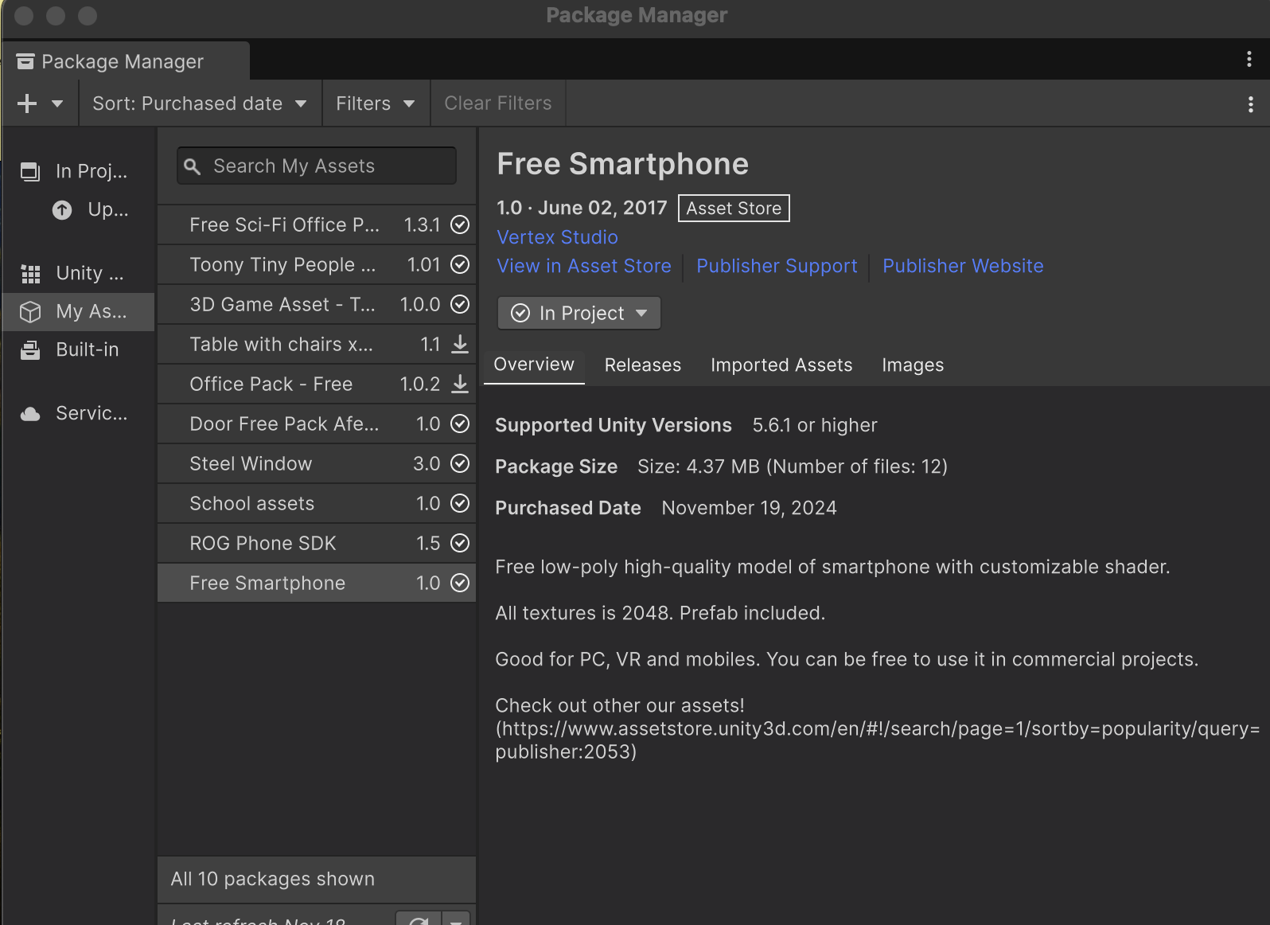

**Unity Drafts:**

1. **Setup three separate locations for three different scenes:**

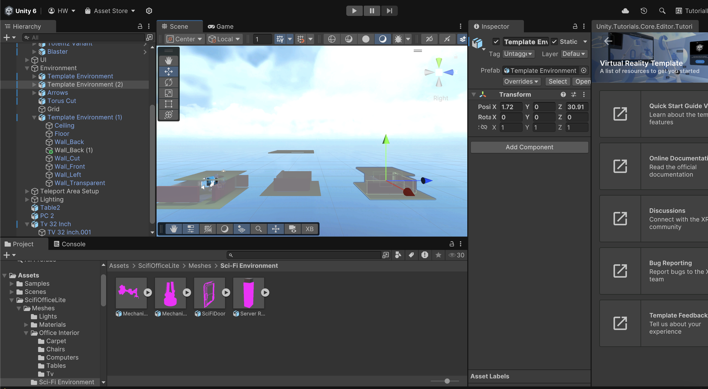

1. **Adding necessary key elements, doors, people in the first shot**

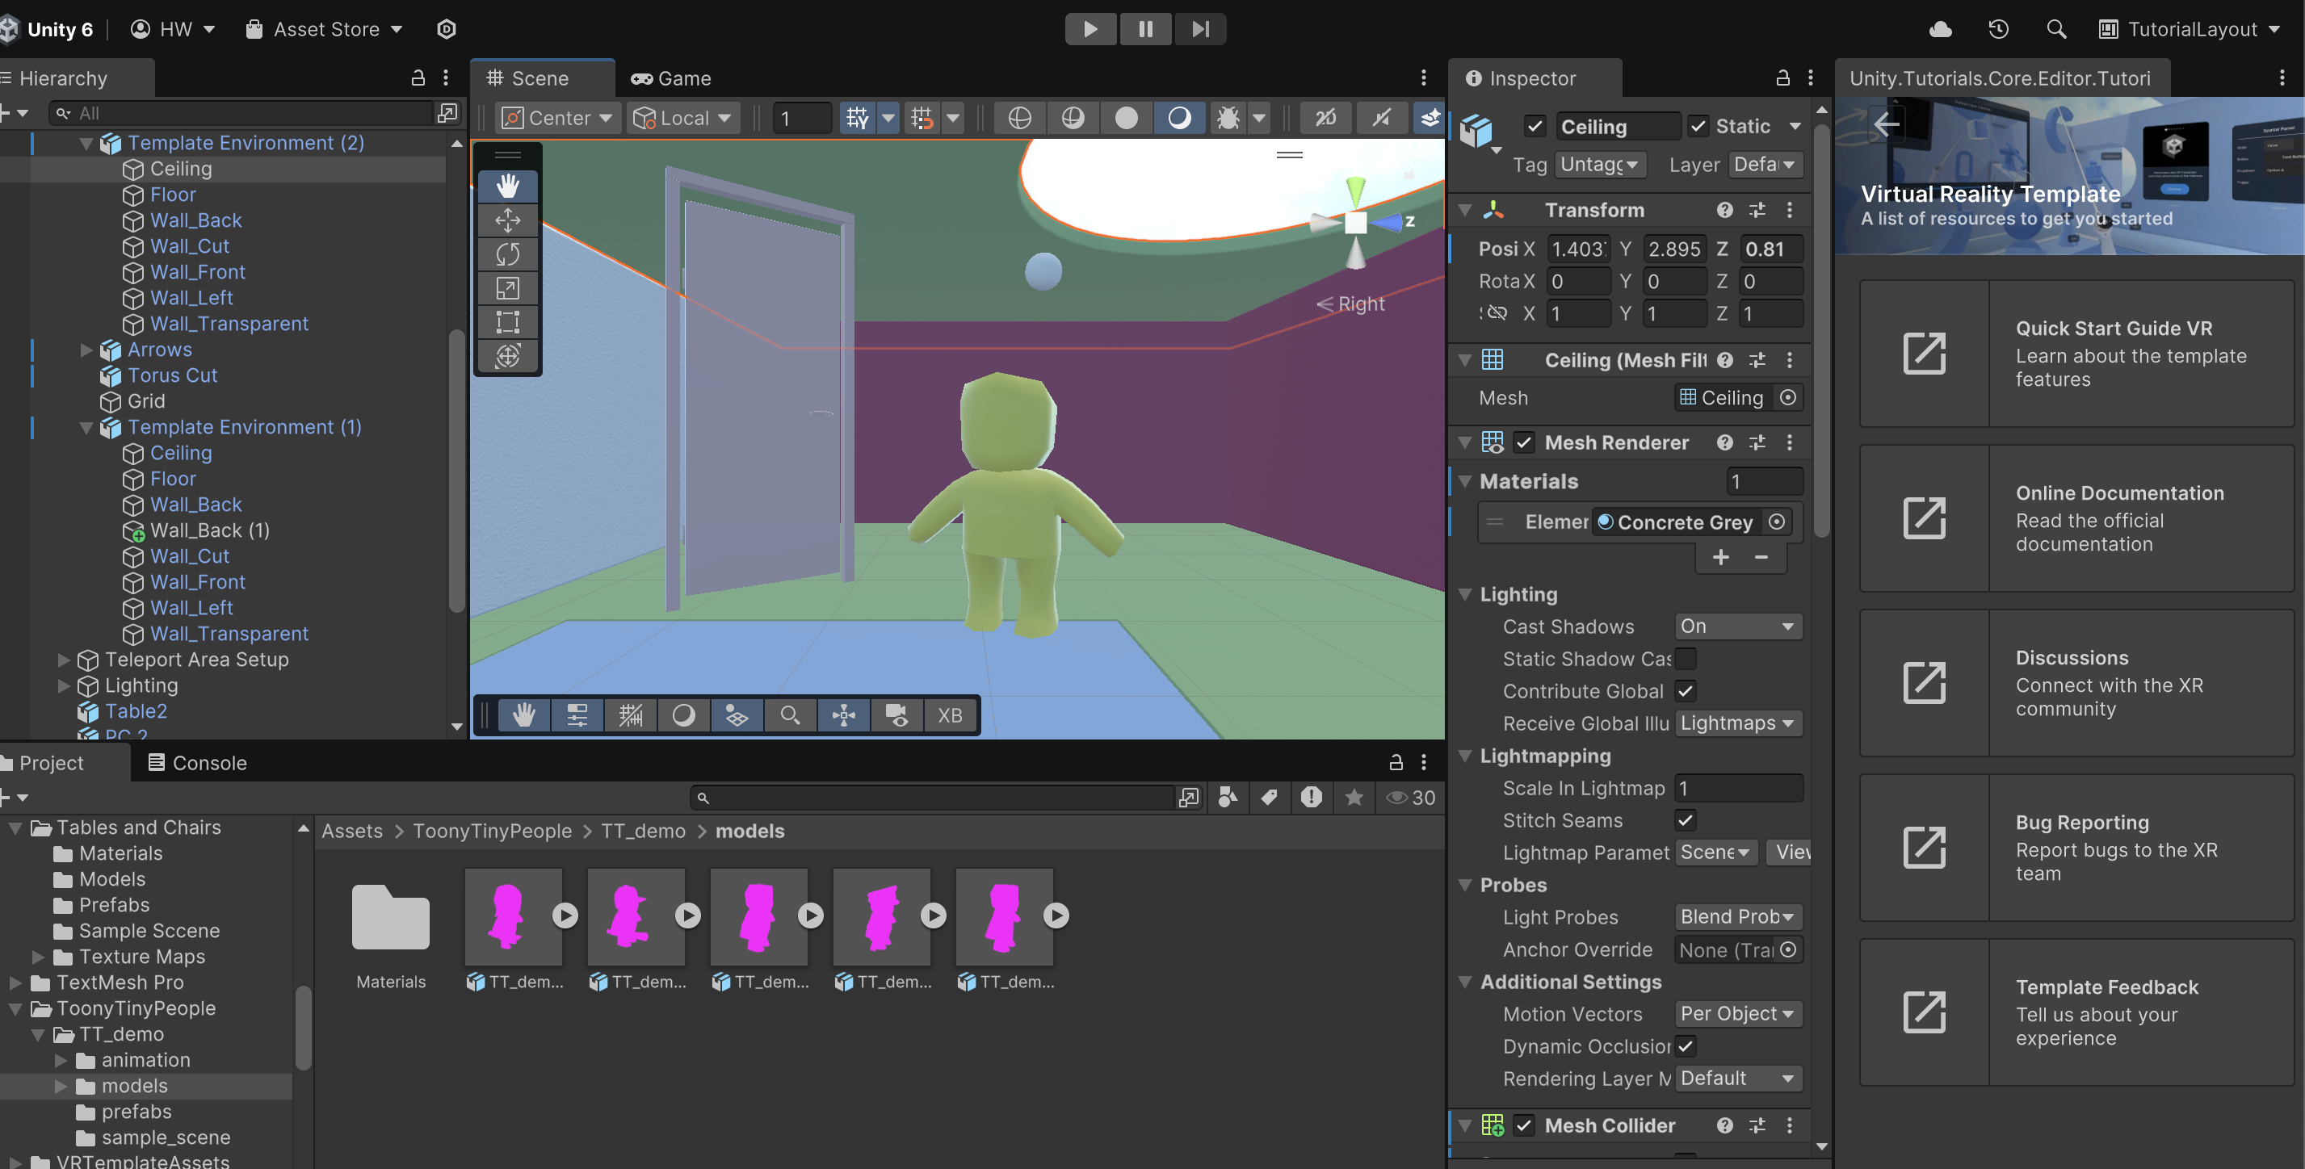

1. **Adding more necessary elements, this time pc, computer, and chair**

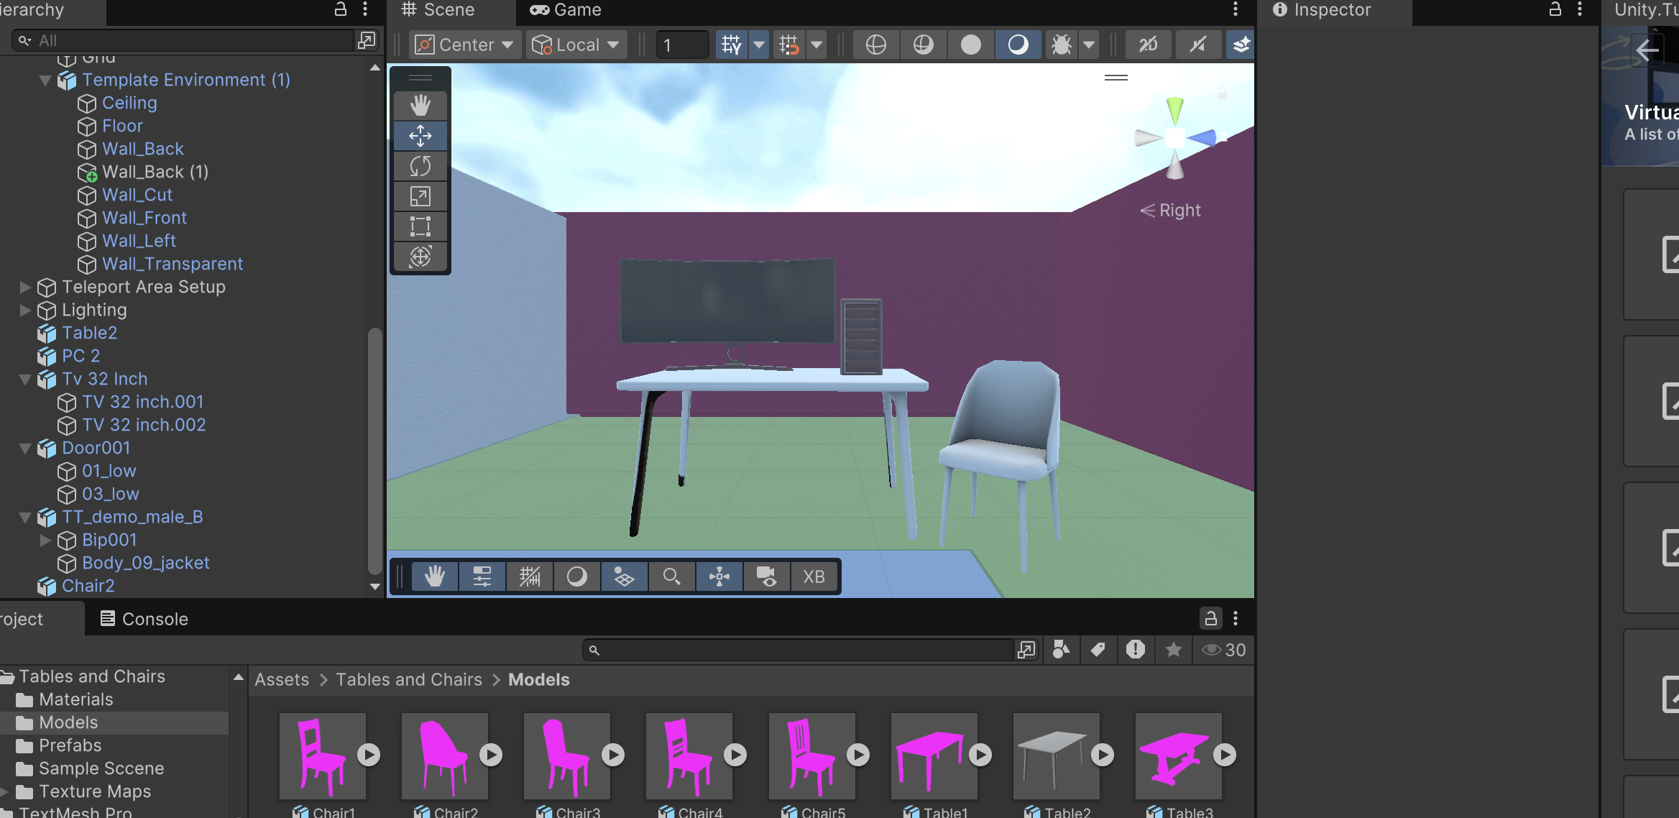

1. **Next, I was able to add a whiteboard and even some windows next to the whiteboard as per the plan**

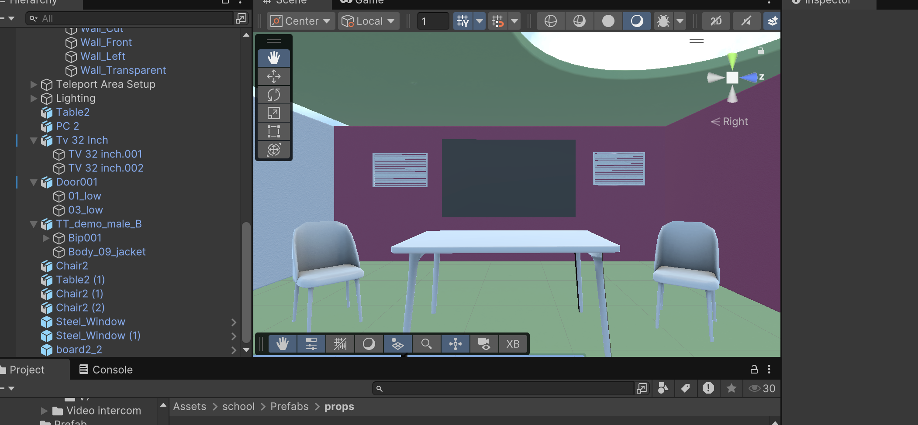

**Added the phone and person**

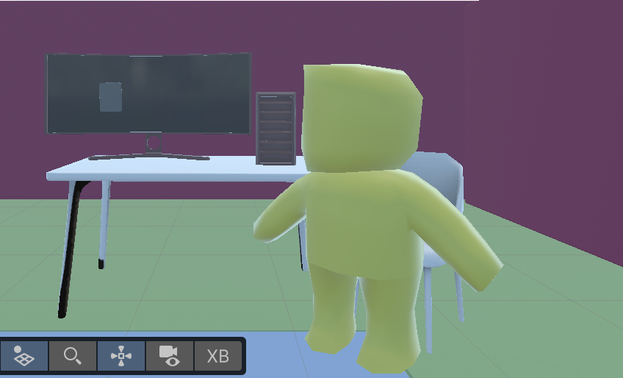

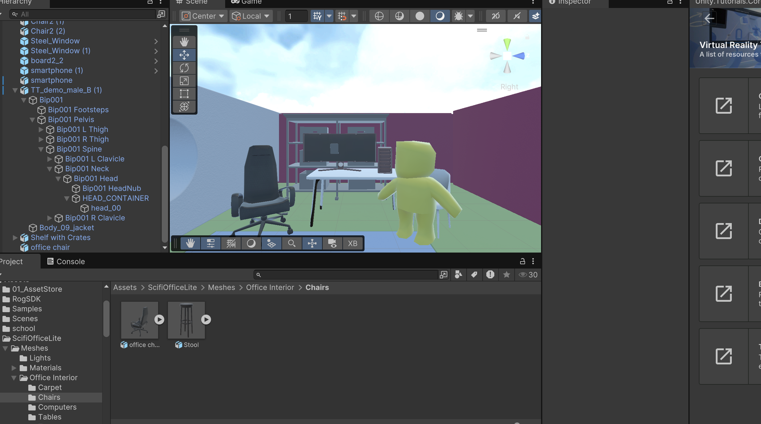

**Adding text**

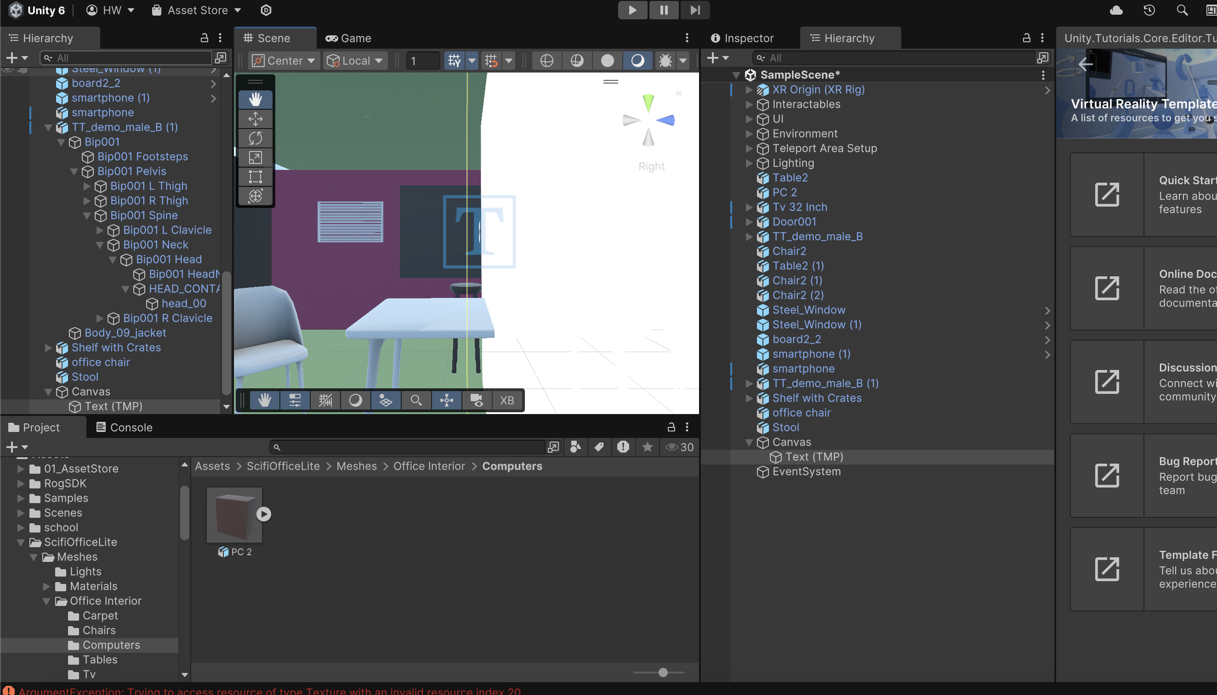

**I added some text which I was super happy about!**

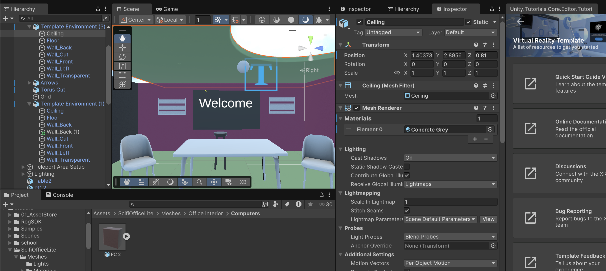

**Made the entrance feel more like an office**

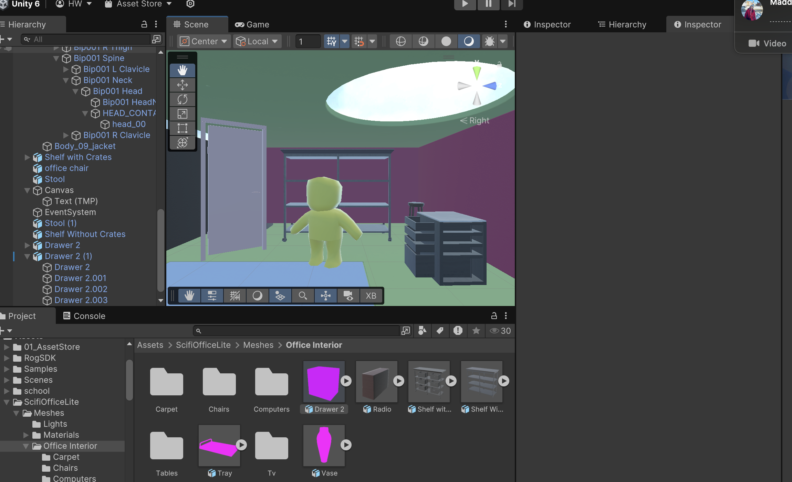

**Building more**

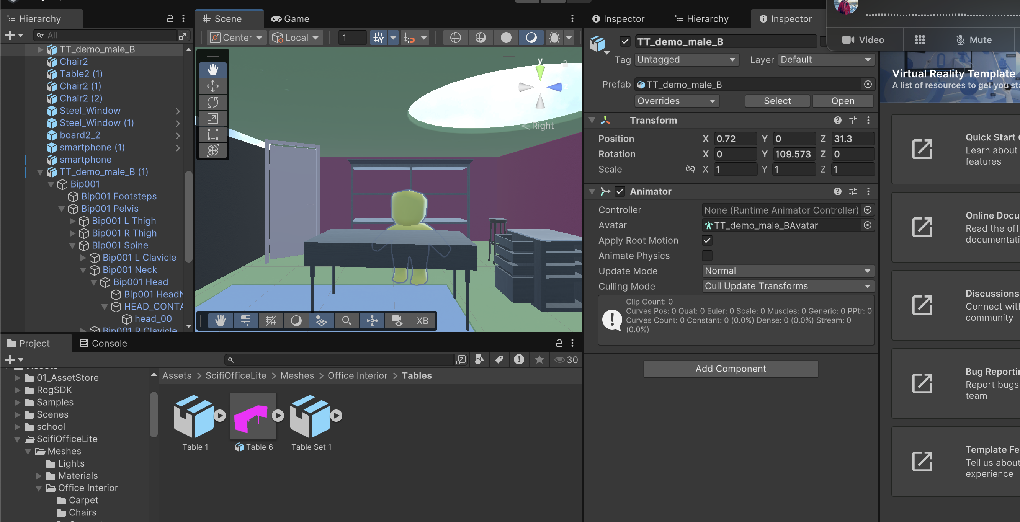

**+ my feedback post meeting was to make my idea more complicated,**

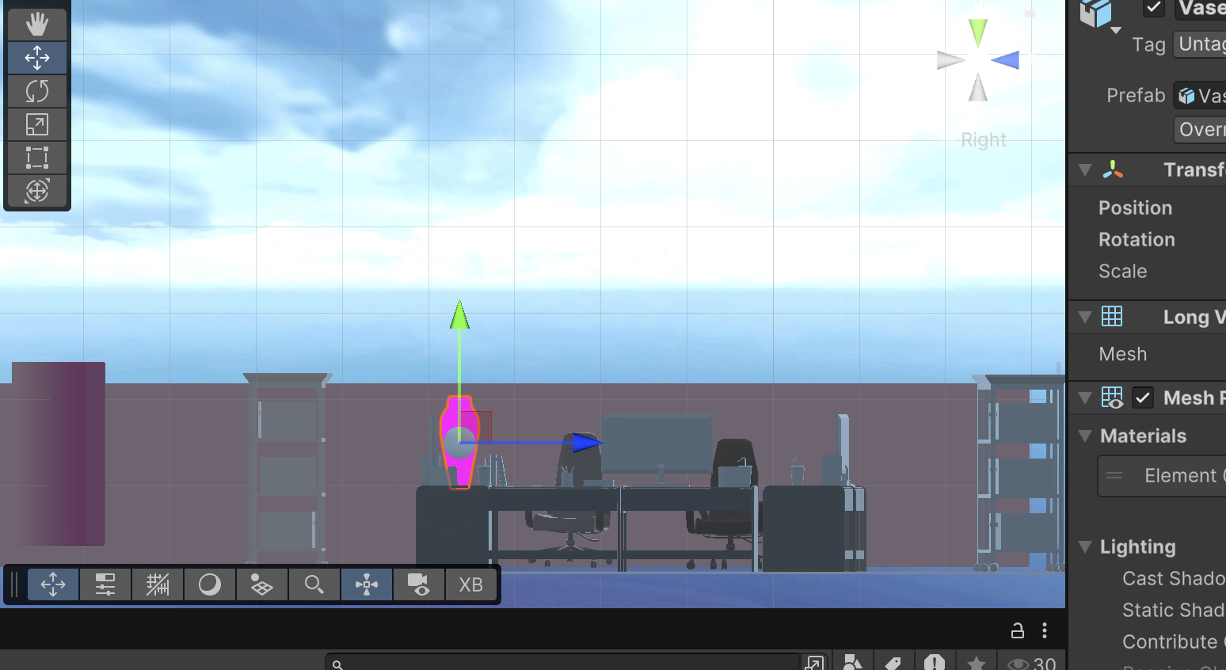

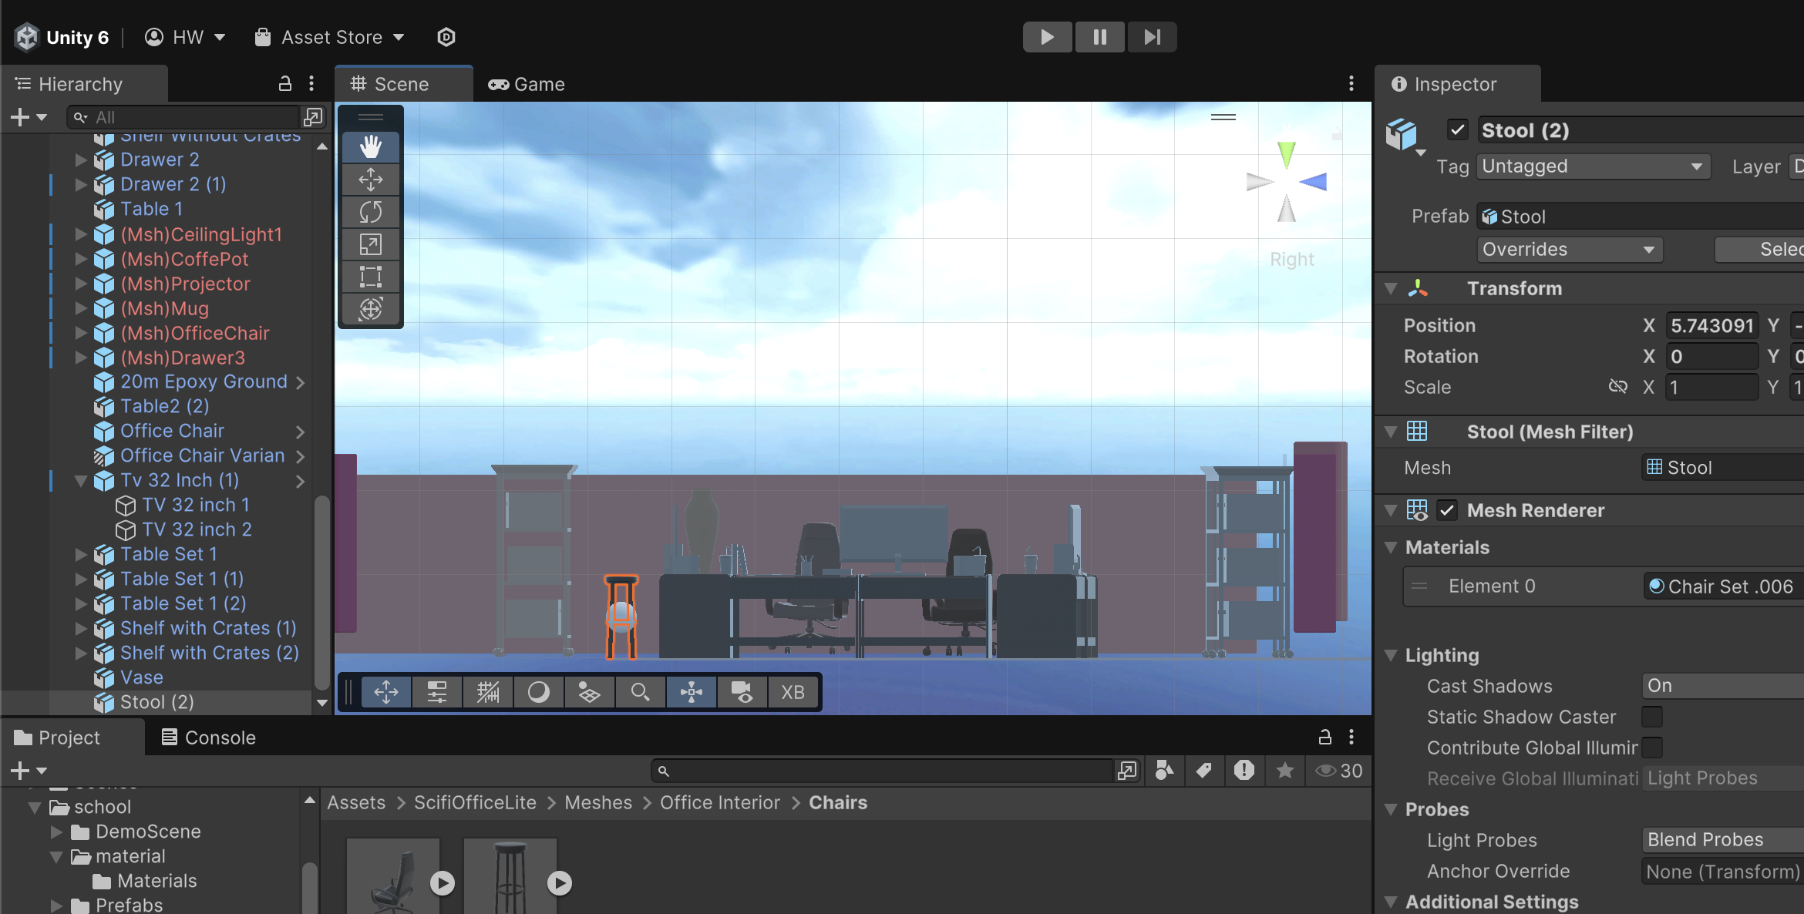

**Office is looking better**

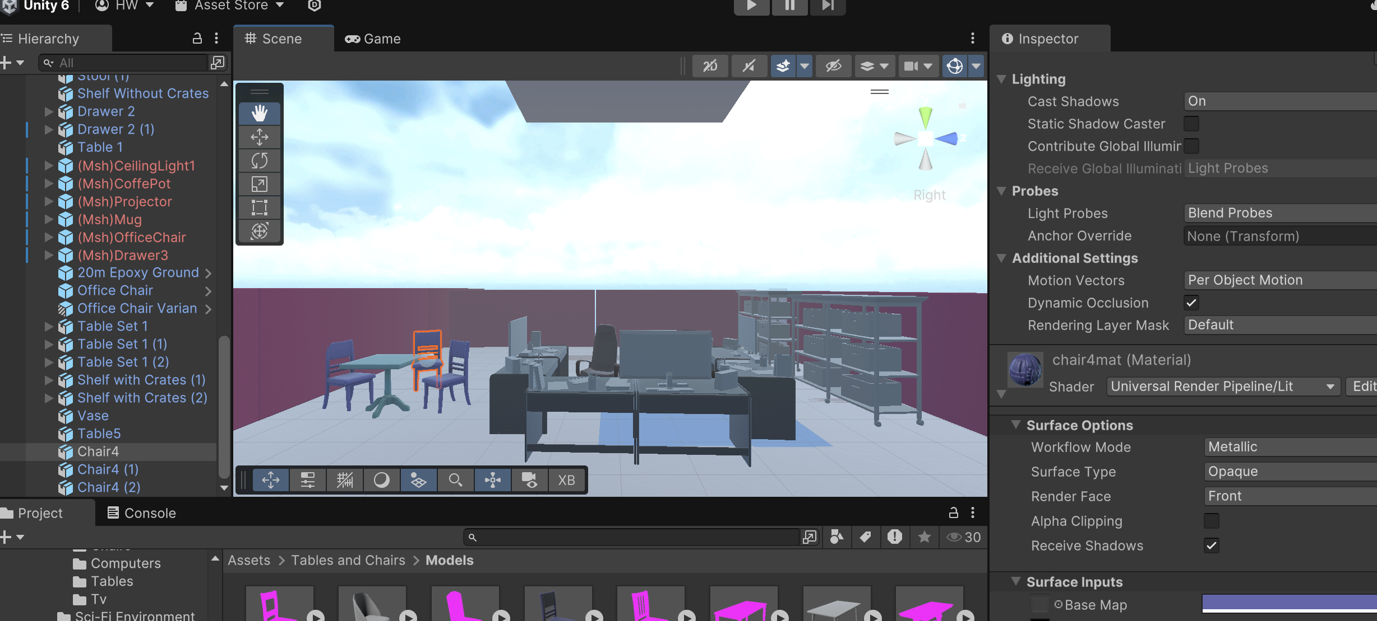

**Added my text:**

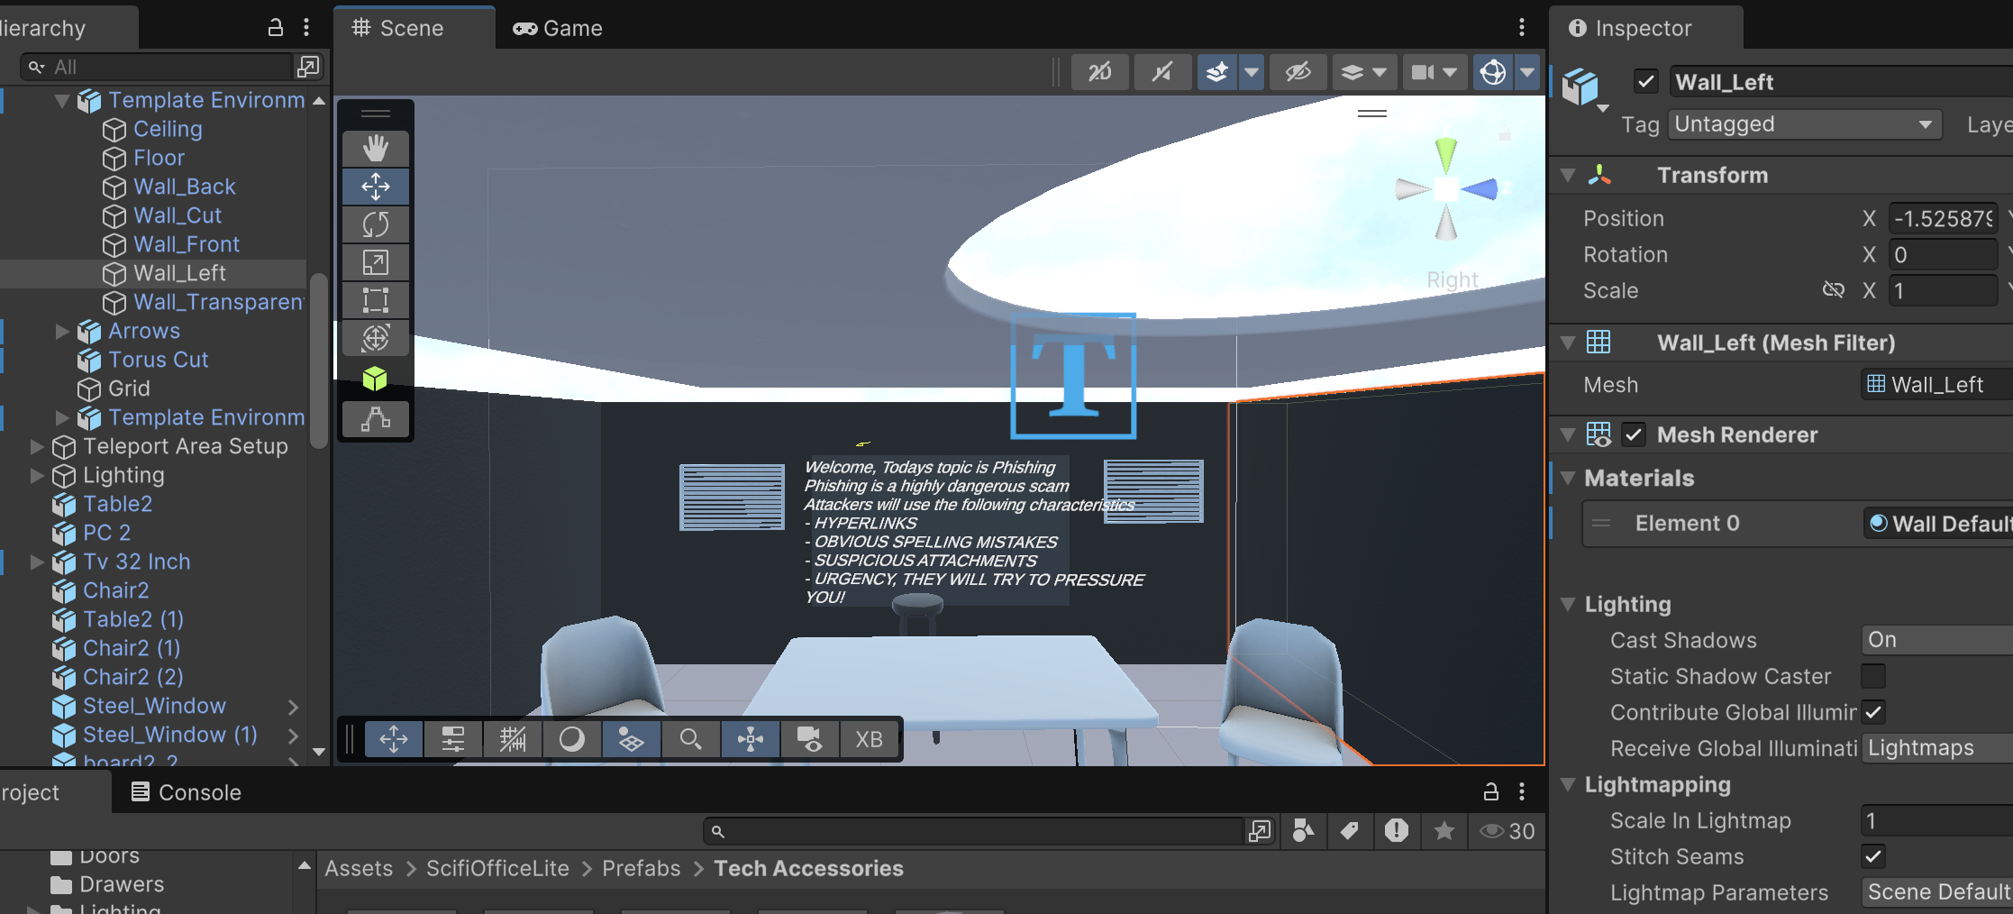

**Added phone and VR code:**

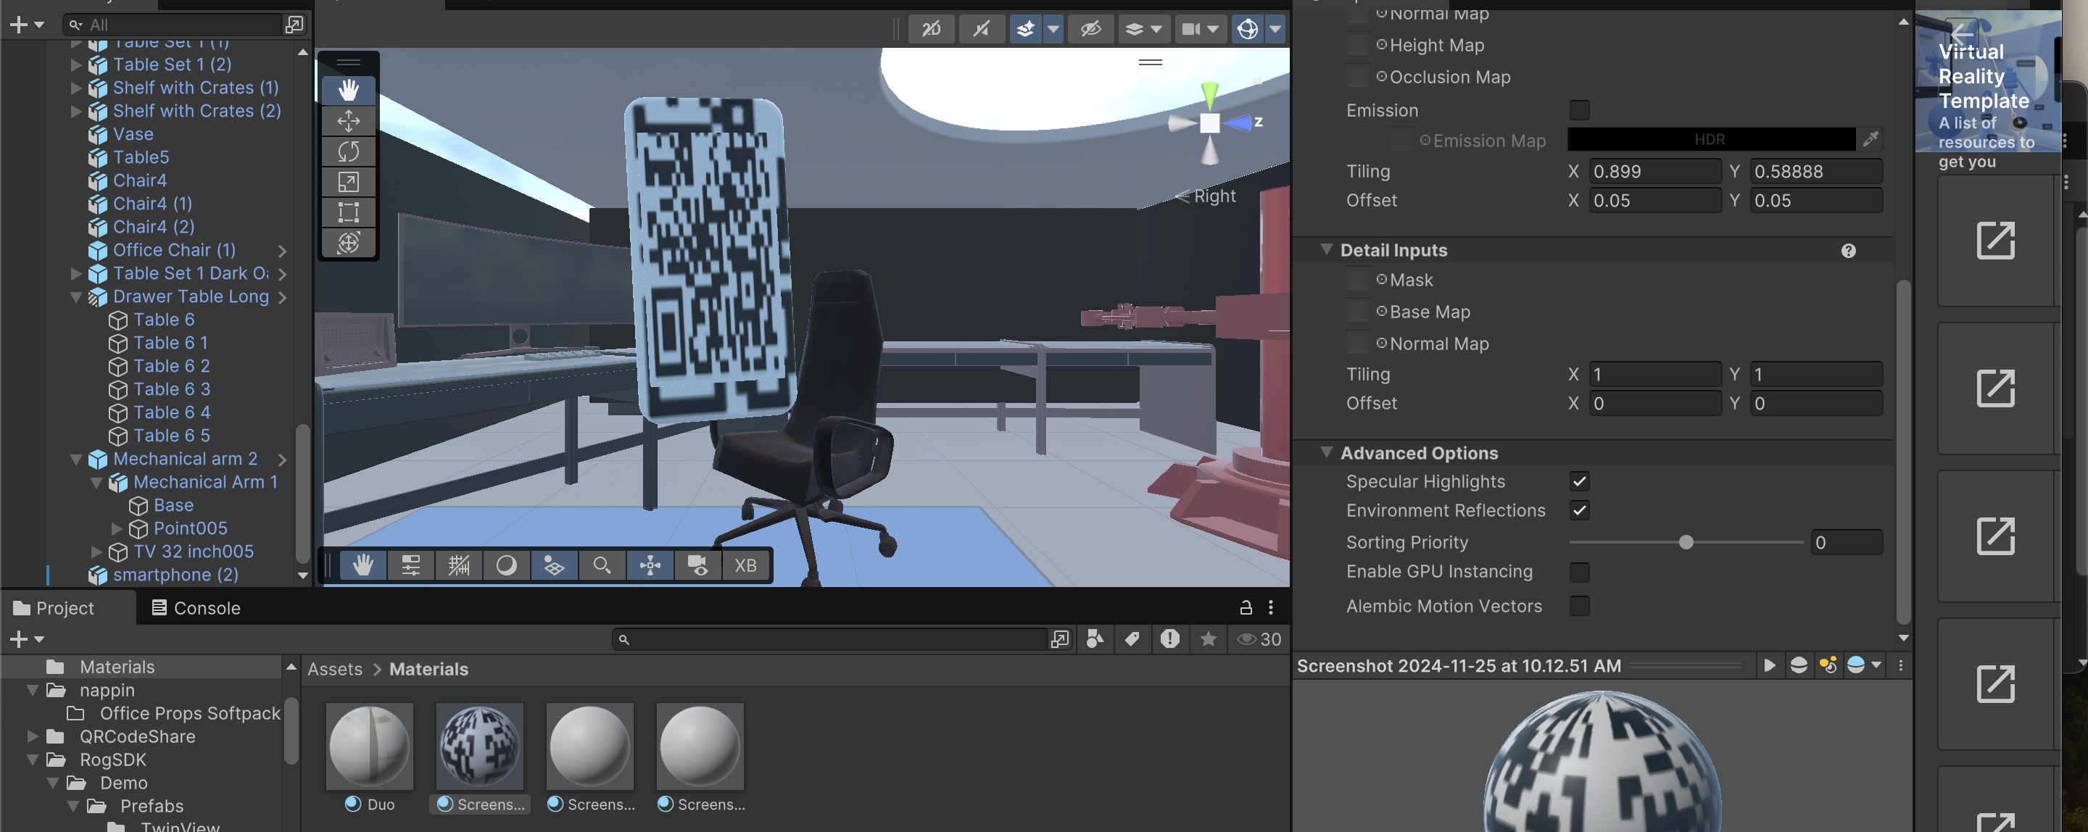

**Added examples of safe and dangerous emails:**

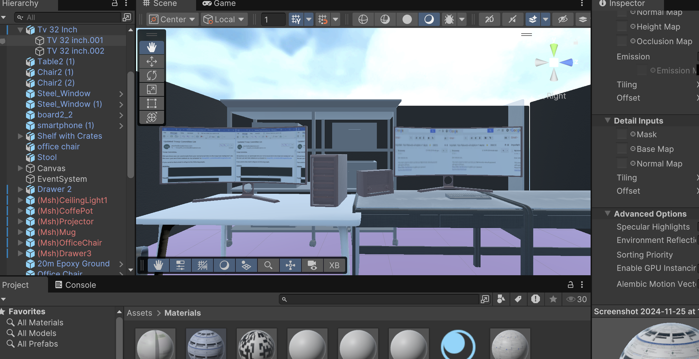

**Added whiteboard to explain the game:**

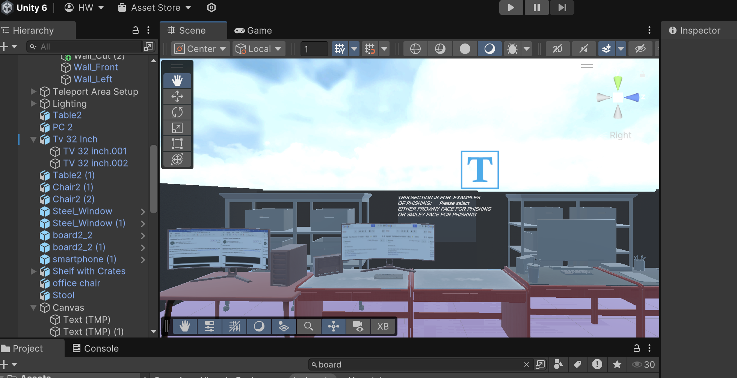

**Added my faces:**



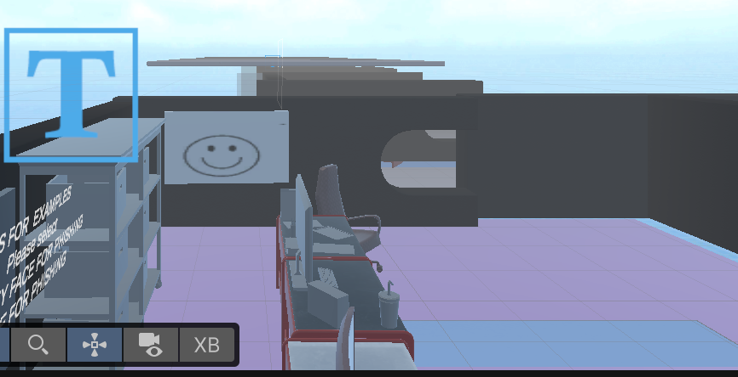

**Added code, to make the faces interactive**

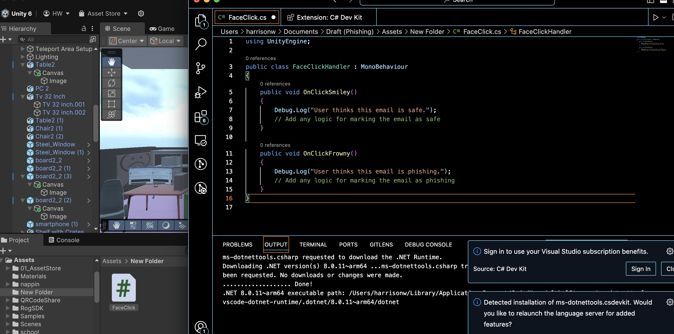

**+ COMPLETED A ROOM WOOP** **WOOP:**

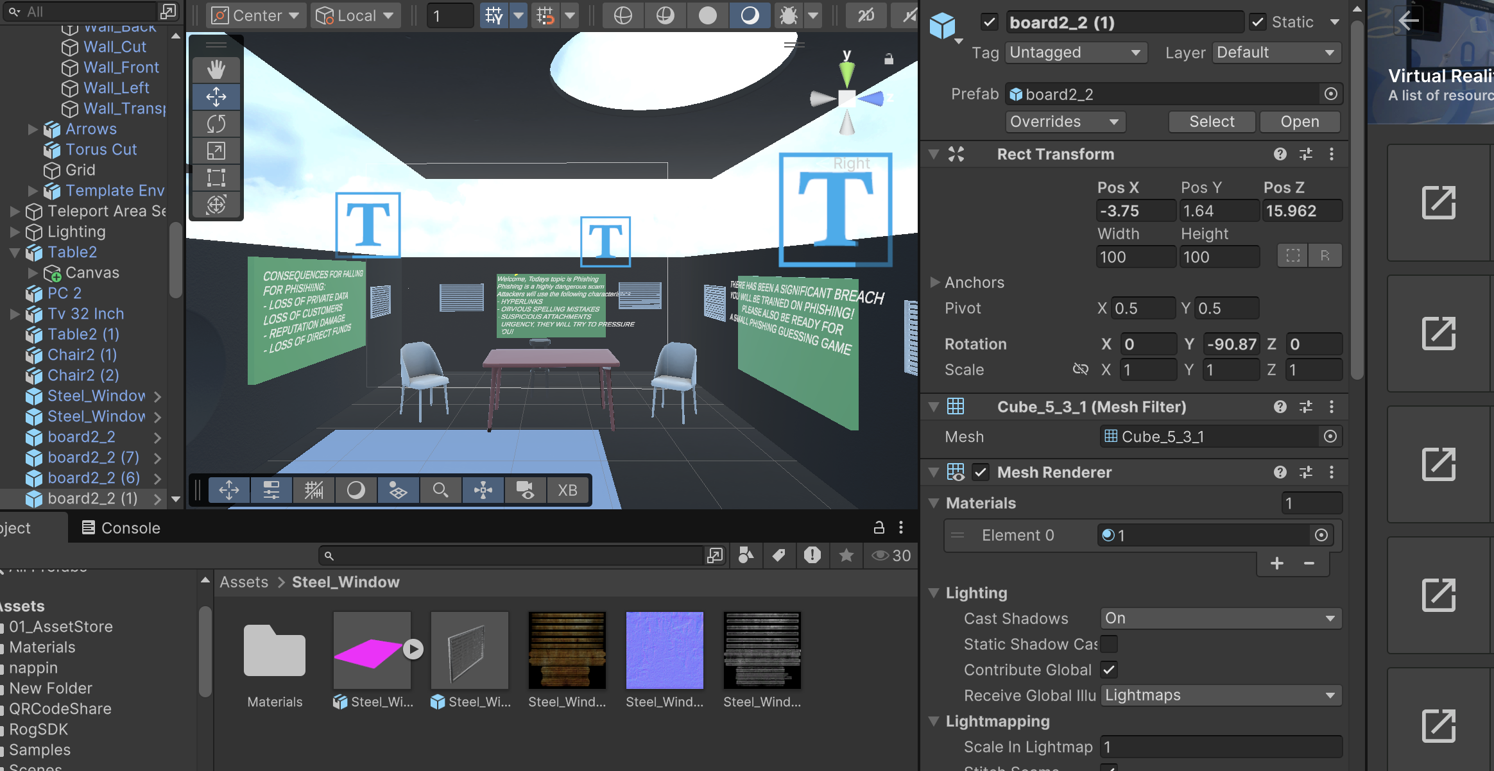

**Added a person:**

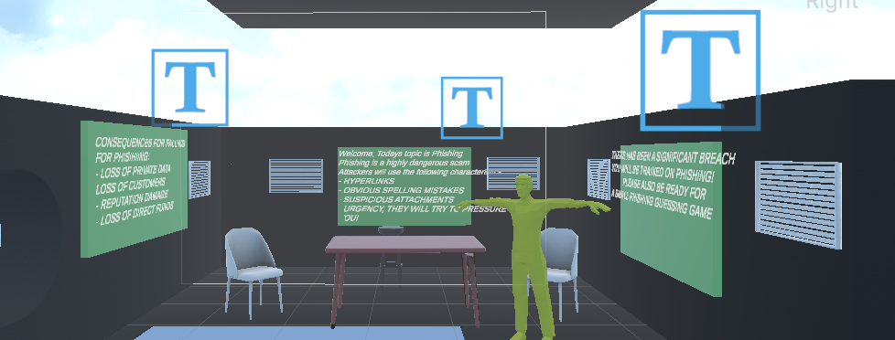

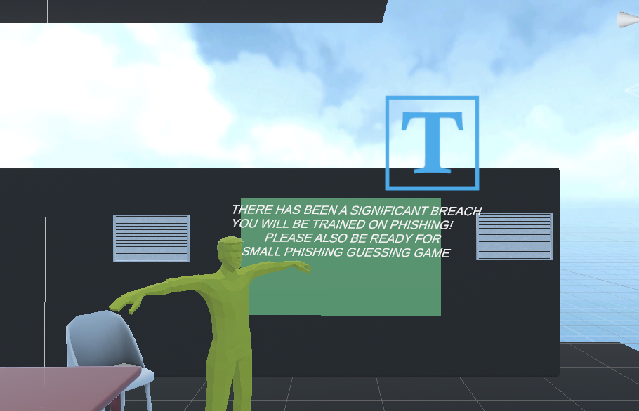

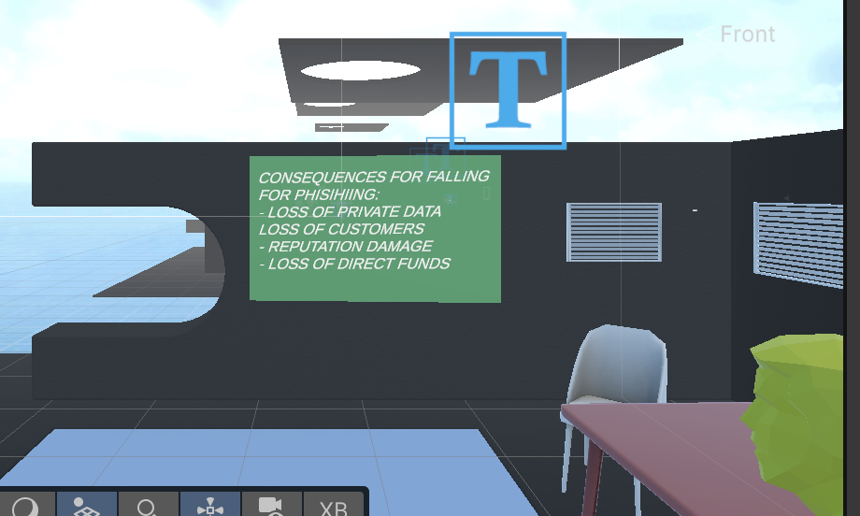

**+ Fixed the complexation on the people for more realism:**

**+ Also, I lost the save for my VR environment and had to start a new one. It gave me an opportunity to redo my work. Here is the reception:**

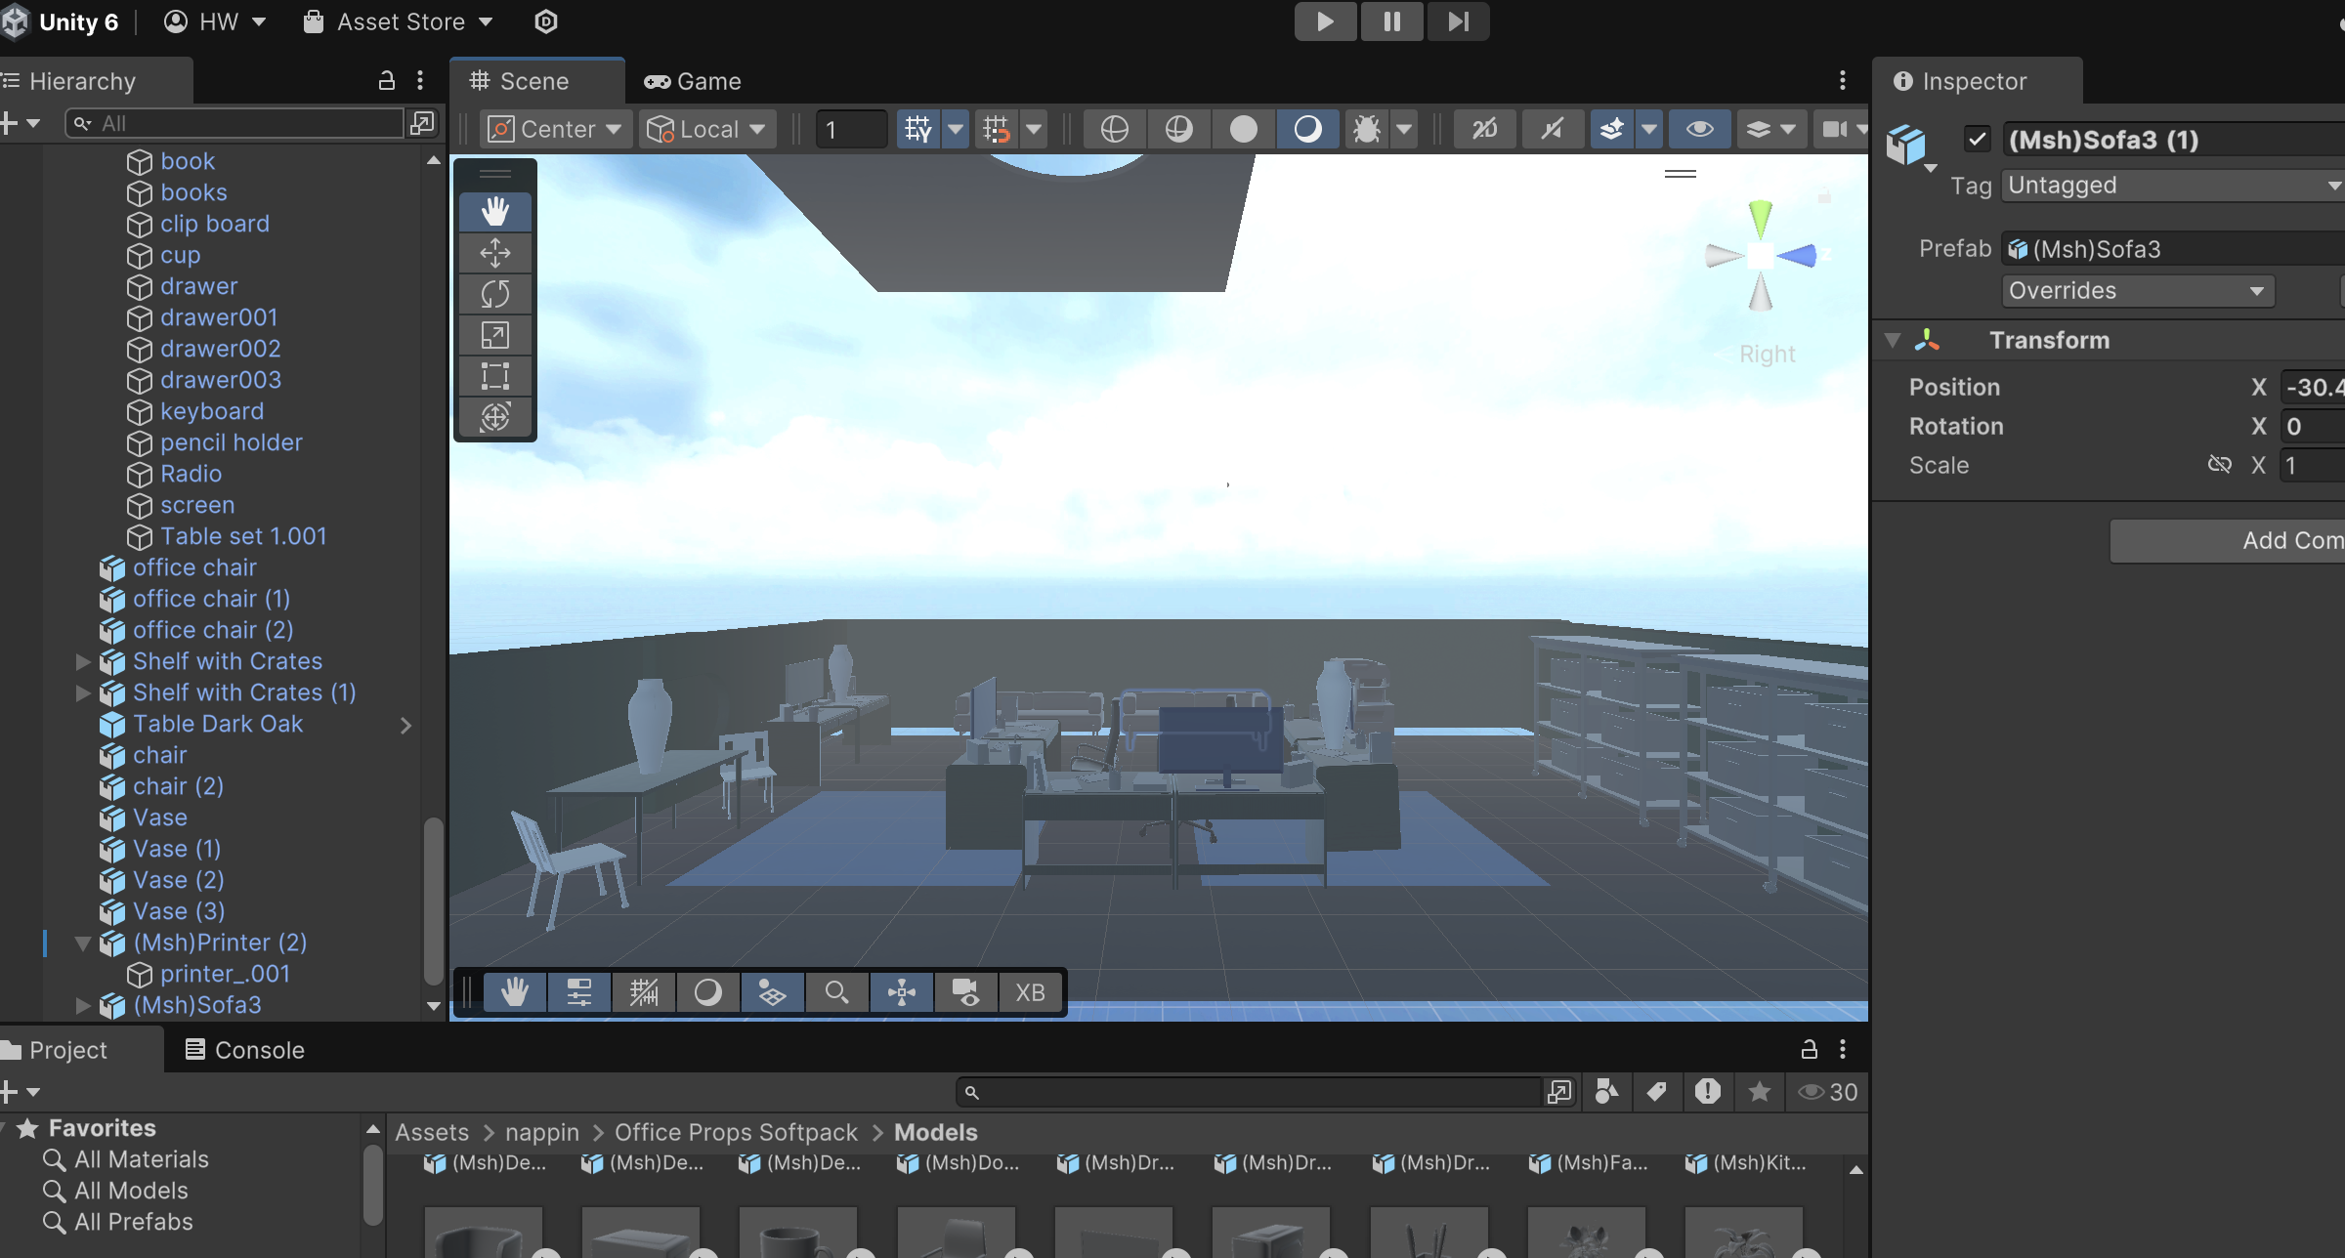

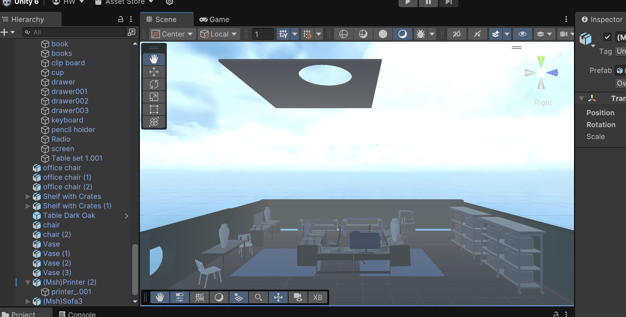

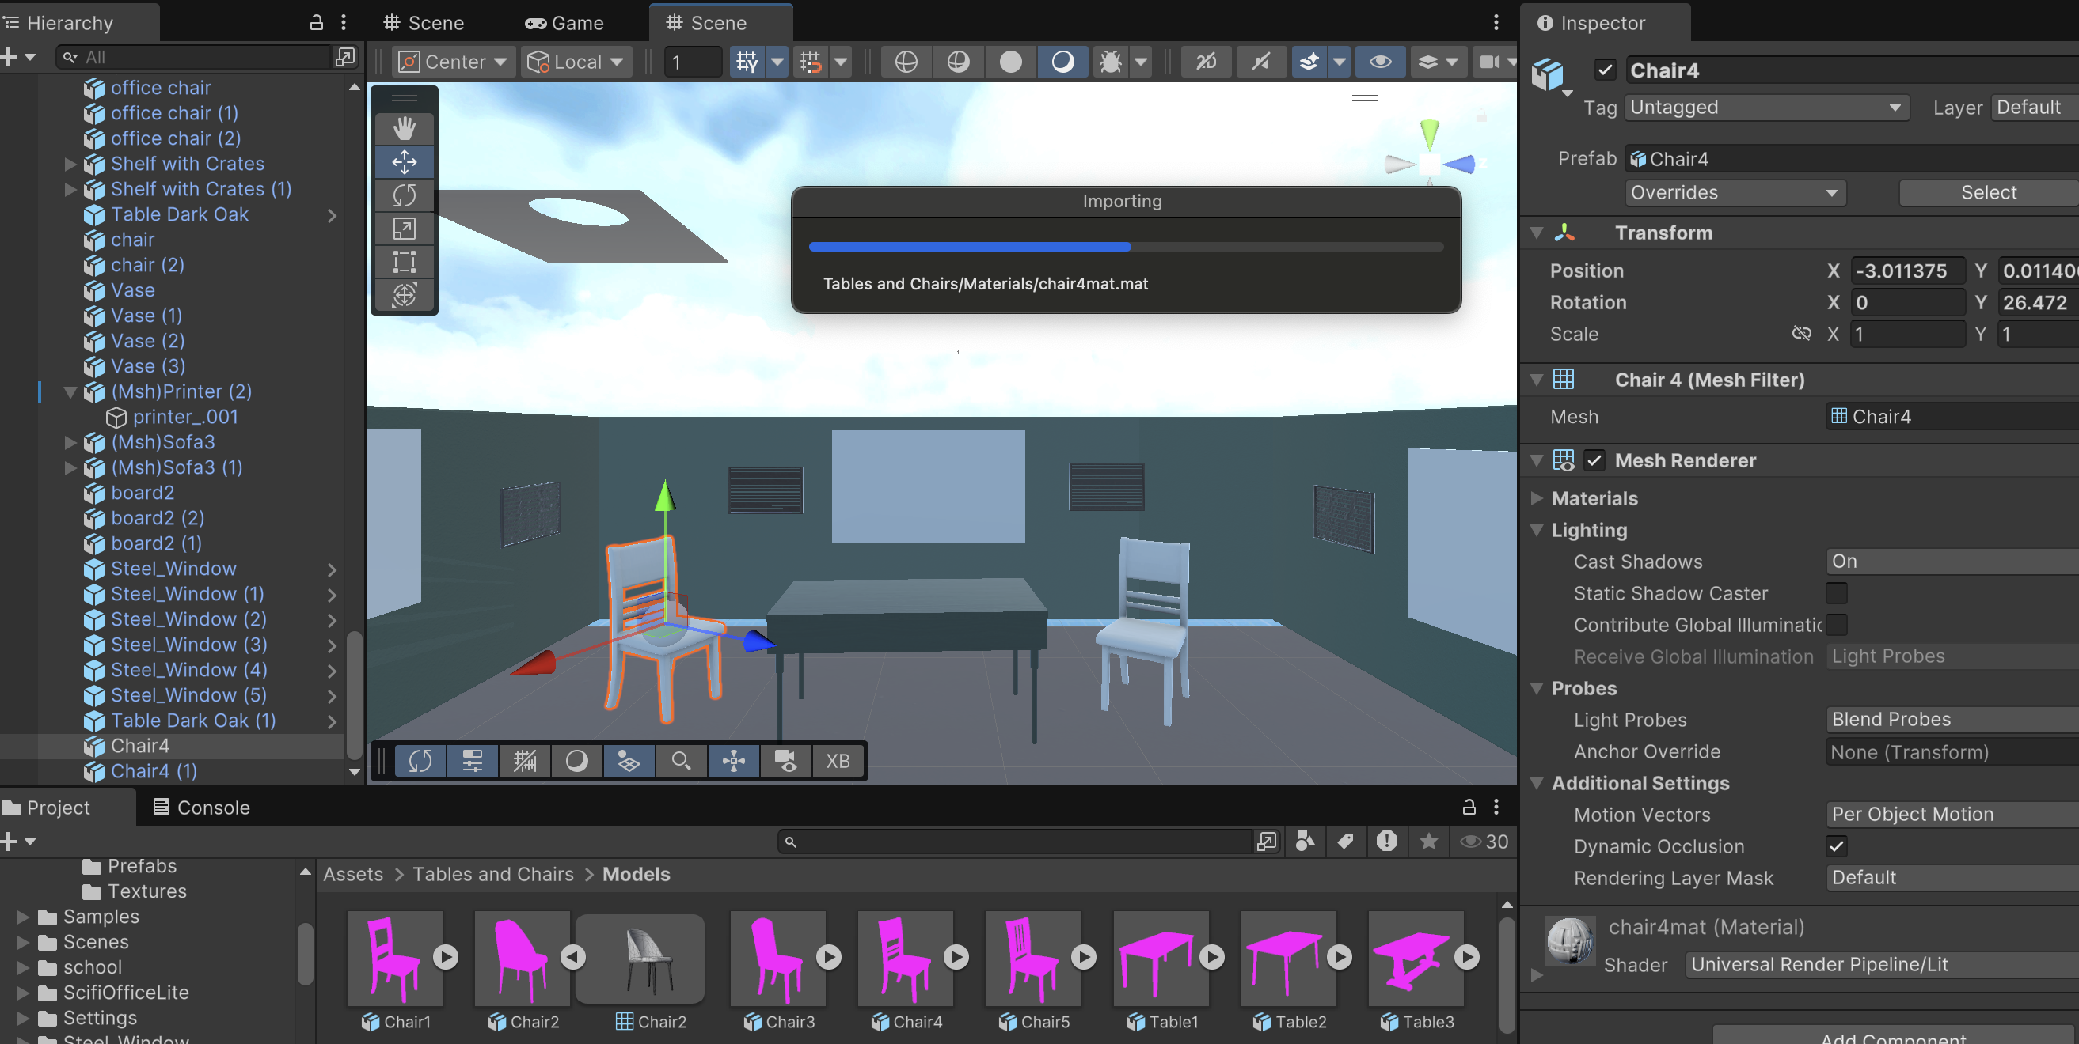

**+ References:**

* Ahmad, Md.O. (2023). BAuth-ZKP—A Blockchain-Based Multi-Factor Authentication Mechanism for Securing Smart Cities. *Sensors*, 23(5), p.2757. doi:https://doi.org/10.3390/s23052757.
* Microsoft 2020 Phishing report
* Logothetis, I., Sfyrakis, M. and Vidakis, N. (2023). EduARdo—Unity Components for Augmented Reality Environments. *Information*, 14(4), p.252. doi:https://doi.org/10.3390/info14040252.
* Shekokar,M.(2015). An Ideal Approach for Detection and Prevention of Phishing Attacks. *Procedia Computer Science*, 49, pp.82–91. doi:https://doi.org/10.1016/j.procs.2015.04.230.

**+ Potential Storyboard:**